Train (1 hero)
Train is a quick one hero format focused on randomness and quick games. Skilltest 15 min if u will.

History
In the past it used to have a bunker, but was removed past the Test versions.
There used to be breaks too before the revolutionary +3/+4 patches.
Thanks to the testers: backseater_extraordinaire, homm3watcher and ordulops007

Rules
Play on 130%/160% difficulty (Hard/Expert)
Recommended Timer: Classic 1 min, Simultaneous Turns: 125,
Town, Color Trade/Random, Tournament Rules: ON
Starting zone must have DD scroll, otherwise you can technical restart (up to 114)

Info
L Sized map with no underground
Starting Biome has 2 Gold Mines, Wood and Ore, DD scroll and sometimes Stables
In Town Zones (starting zone too) creatures are always willing to join for gold. On conflux ones always neutrals.

Non-town Zones have either 5 T6 dwells or 2 T7 dwells, also sometimes T4 unit boxes.
Desert is very rich zone with lots of Relics/Topes and Exotic Dragon Dwellings

Many mediocre and too overpowered artifacts are banned.
Schools of magic with the least amount of banned spells: Water, Fire
Schools of magic with the highest amount of banned spells: Earth, Air
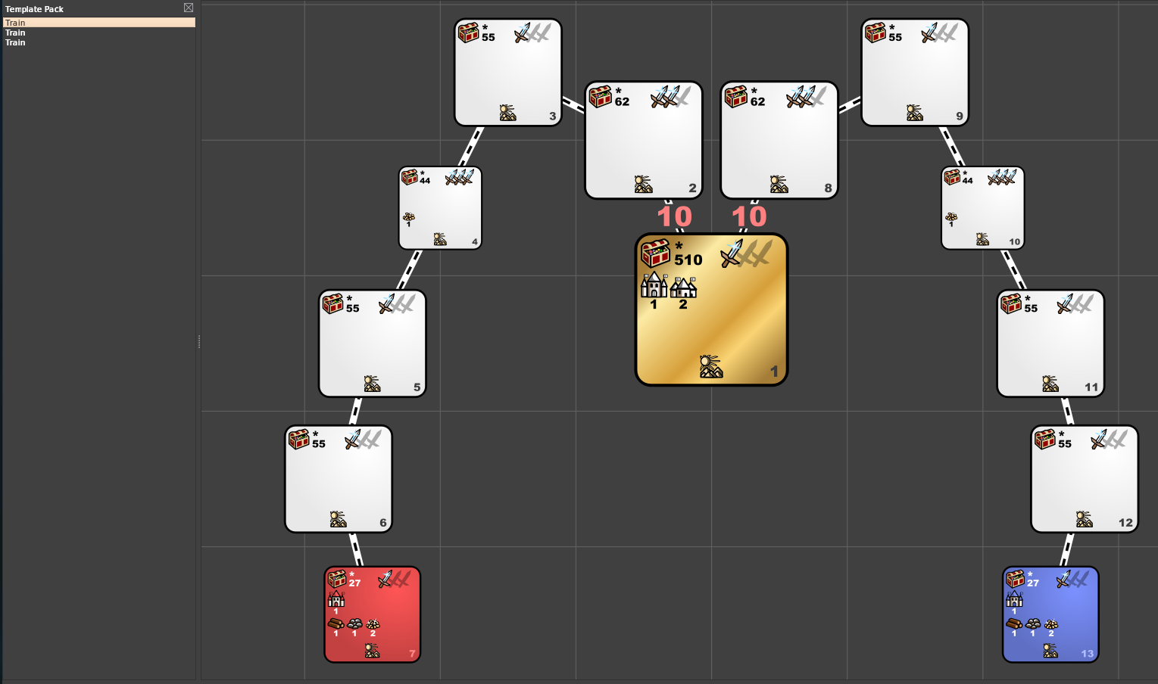
Pirate Wars (8 heroes)
These rich unexplored areas lured Pirates from nearby Seas. With the help of Artificers' Airships broad on!

History
Fun fact, it took me about a year to release it from the first mention of me working on it on the discord server.
This template was finished quickly after factory release to test new features.

Rules
Play on 160% difficulty (Expert)
Recommended Timer: Classic 4 min, Simultaneous Turns: 117,
Town, Color Trade/Random, Tournament Rules: ON

Info
You start in a rich biome with many Hives and Pirate Caverns, 2 Mines, Airship Yards, t1 monster Pandoras, t4-t7 Dwellings and a lot of gold around. Always rough terrain (so pirate caverns spawn)

To enter middle zone which is always Factory faction, you need Airship. You'll find there random treasure, most likely Serpentarium, Gantry, Dragon Utopias, Pandora Boxes and Control Scrolls. There's also a smaller zone floating on the sea, it is in control of Pirates who are willing to join for gold.

Banned Spells: Implo, Arma, Resurection, most Mind spells, Summons
Banned Artis: Teapot. Luck, Morale, most Combination artis, Orbs, Speed artis
Enabled: Admiral's Hat, Wizard's Well, Copium, Goose
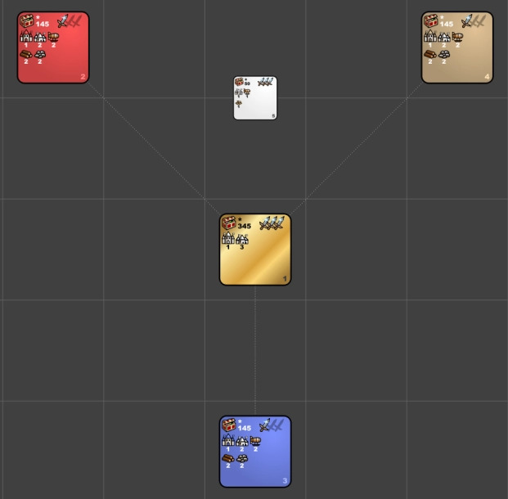
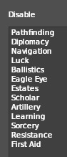
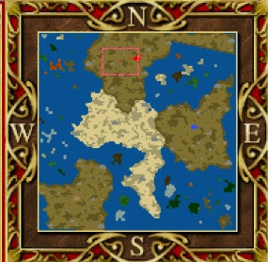

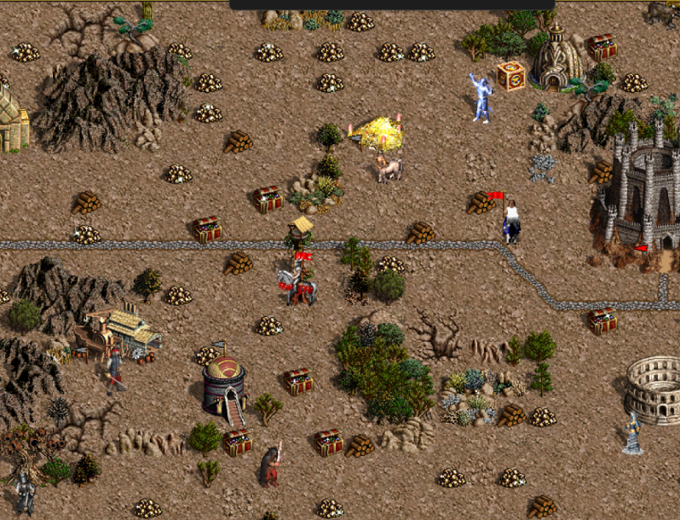
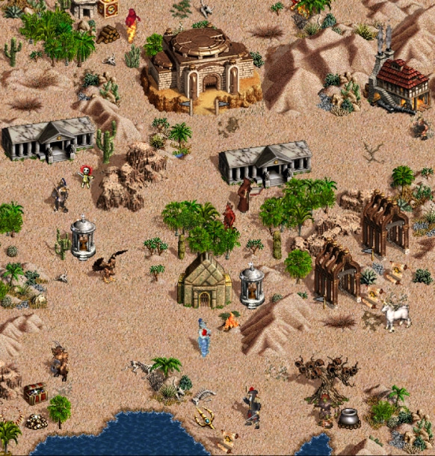
Fart (1 hero)
Fart was an attempt to fix Poo by me, not as good as template on next page.

History
Remake of poo which was remake of pee.
Pee was 8xm8 with some banned artifacts, spells, skills and artifacts by me.
Poo was Pee but bigger and with 4 insane zones with unlimited amount of t7 unit boxes, t7 dwellings, topes and a lot of connections are via monoliths. Since there’s only so many 2 way monoliths, half of connections would be bugged 1 way monoliths. Also due to Pandora Box limit 2 insane zones would usually be just dwellings and relics. By Dings.

Rules
Play on 160% difficulty (Expert)
Recommended Timer: Classic 4 min, Simultaneous Turns: 411, Town: Random,
Color: Red – Dings, Blue – Ledan, Tan – Griffin, Tournament Rules: ON

Info
It is modified 8xm8 but with guaranteed low tier dwellings in biome and 4 new neutral zones with exotic dragons. The only way to travel to them is via fly/dd, which you had to highroll from topes. Fart 1.1 added more guaranteed topes, still a gamble tho.
